NATIONAL TEXTILE UNIVERSITY, FAISALABAD
DEPARTMENT OF COMPUTER SCIENCE
Course: Mobile Application Development
COURSE CODE: CSE-4078
GROUP MEMBERS:
- Muhammad Talha Khalid (Registration: 23-NTU-CS 1196)
- Ali Ul Murtaza Alvi (Registration: 23-NTU-CS 1244)
Submitted TO: Sir Rehan Sarwar
Submitted Date: 18 May 2026

Contents
Smart Cricket Scorer - Flutter App Documentation 4
1. Introduction 4
2. Project Overview 4
3. Project Structure 4
4. Core Features 5
5. App Screens 6
Splash & Auth Screens 6
Dashboard 7
New Match Setup 8
Live Scoring Interface 9
Tournament Dashboard 10
Teams Management 13
History Management 14
6. Tools & Frameworks 17
7. Installation & Setup 17
8. Application Architecture 17
9. Security & Privacy 17
10. Version Control 17
11. Packages Used 17
12. Future Enhancements 18

Smart Cricket Scorer - Flutter App Documentation

1. Introduction
In the modern era of sports, keeping accurate and real-time records of matches is essential for players, organizers, and fans. Traditional paper-based cricket scoring is often prone to errors, tedious to maintain, and difficult to share with a wider audience. Digital solutions have emerged as an effective way to simplify cricket match management, offering accuracy and instant updates.
Smart Cricket Scorer is a mobile-based application developed to address these needs by providing a digital platform that simplifies the entire cricket scoring and tournament management process. The application allows users to create matches, manage teams, track live ball-by-ball scoring, and organize full tournaments efficiently through a single interface. By leveraging modern mobile technologies, Smart Cricket Scorer eliminates manual tallying, potential miscalculations, and the hassle of physical scorebooks.

2. Project Overview
Smart Cricket Scorer is a modern, intuitive, and highly scalable mobile application designed to digitalize the cricket scoring experience. The app provides a centralized platform where users can start quick matches, create customized teams, manage full tournaments, and maintain detailed match histories seamlessly using their smartphones.
It is built utilizing modern Flutter development practices, heavily relying on Riverpod for reactive state management, Freezed for immutable data models, and Firebase (Auth & Firestore) for a robust, real-time backend infrastructure.
Target Users: - Local cricket teams and clubs requiring an easy scoring tool. - Tournament organizers seeking automated points tables and scheduling. - Umpires and scorers looking for a secure, digital alternative to paper scorebooks.
Key Goals: - Provide a smooth and intuitive user experience for live scoring. - Ensure reliable local and cloud data storage for match history. - Reduce manual calculation errors through automated strike rotation and run tracking. - Provide declarative routing and modularity using GoRouter.

3. Project Structure
The project is organized using a scalable, feature-based Domain-Driven Architecture, ensuring separation of concerns and high maintainability:
lib/
├── core/ # Shared utilities, routing (GoRouter), constants, and base providers
├── features/ # Independent feature modules
│ ├── dashboard/ # Main entry hub and navigation logic
│ ├── matches/ # Match initialization, toss, and history tracking
│ ├── scoring/ # Live ball-by-ball scoring, undo functionality
│ ├── settings/ # Application preferences
│ ├── teams/ # Team creation and player management
│ └── tournaments/ # Tournament creation and automated points tables
└── main.dart # Application entry point & theme initialization

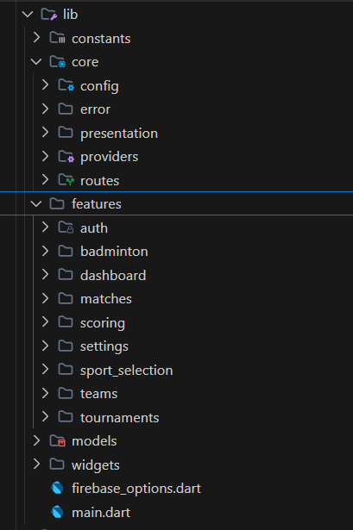
4. Core Features
- Live Ball-by-Ball Scoring: Accurate tracking of runs, extras (wides/no-balls), and wickets with automated batsman strike rotation.
- Undo Functionality: Ability to revert the last action during live scoring securely.
- Team & Player Management: Create custom rosters with unique player IDs.
- Tournament Automation: Automatically updates points tables based on match results.
- Real-Time Cloud Sync: All matches, teams, and tournaments are instantly backed up to Firebase Firestore.
- Authentication: Secure user login using Firebase Auth.

5. App Screens

Splash & Auth Screens
The Splash Screen displays the Smart Cricket Scorer logo, smoothly transitioning to the Firebase-powered Authentication flow (Login/Signup) to secure user data.

Log-in Page:
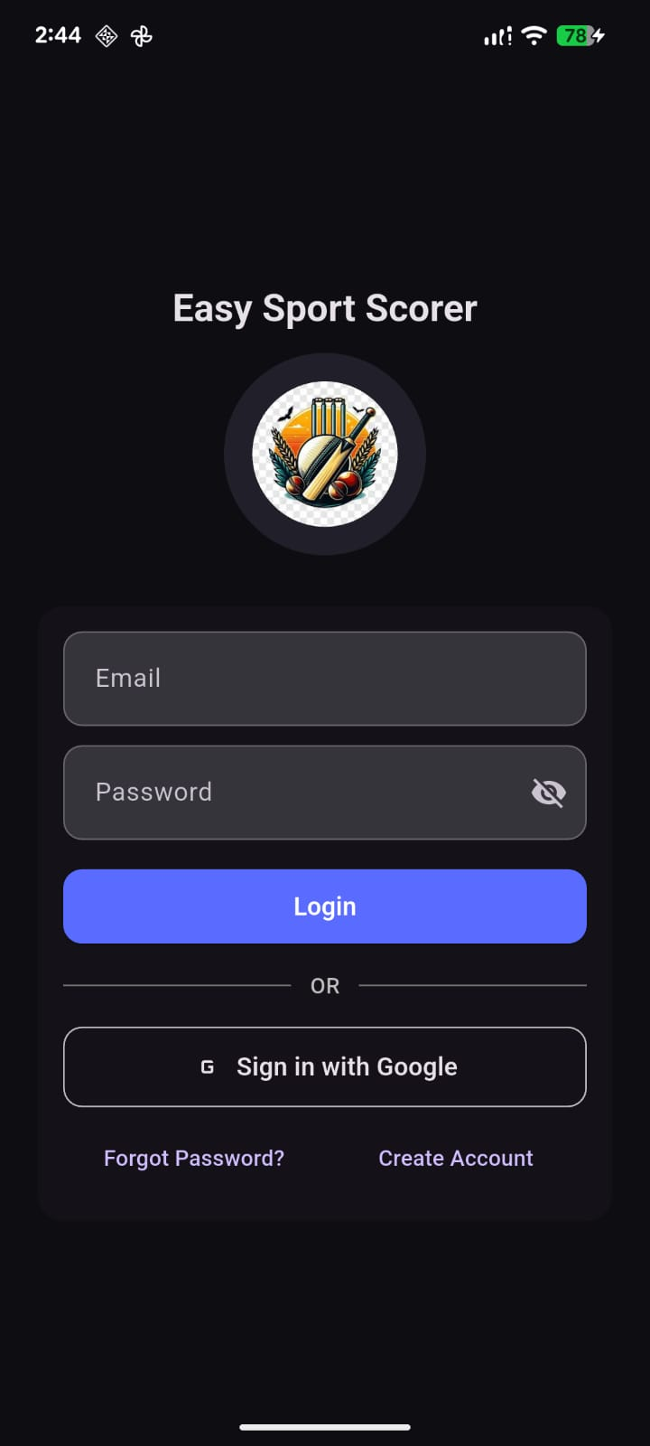

Sign-up Page:
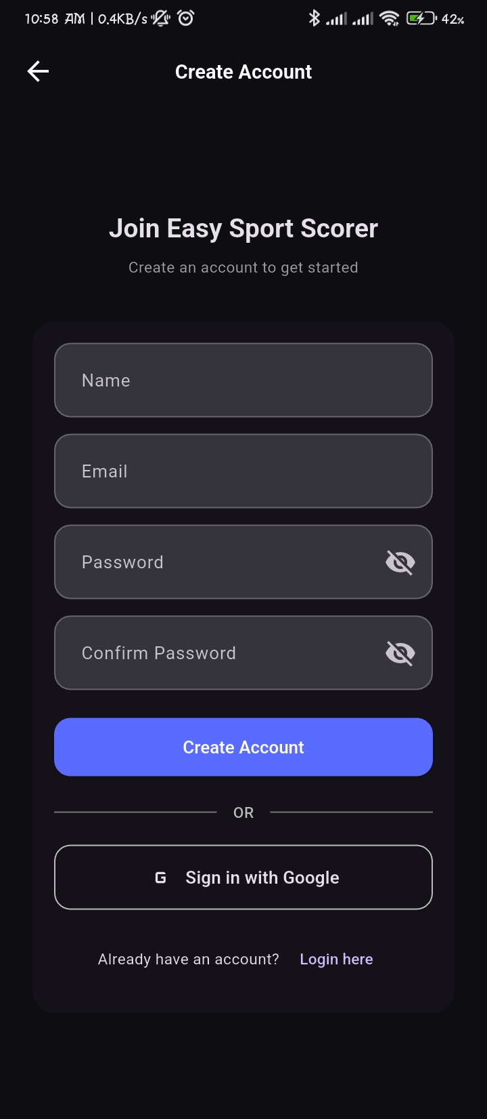

Dashboard
The central hub featuring a clean UI with quick access to start a “New Match”, view “Tournaments”, manage “Teams”, and access application “Settings”.
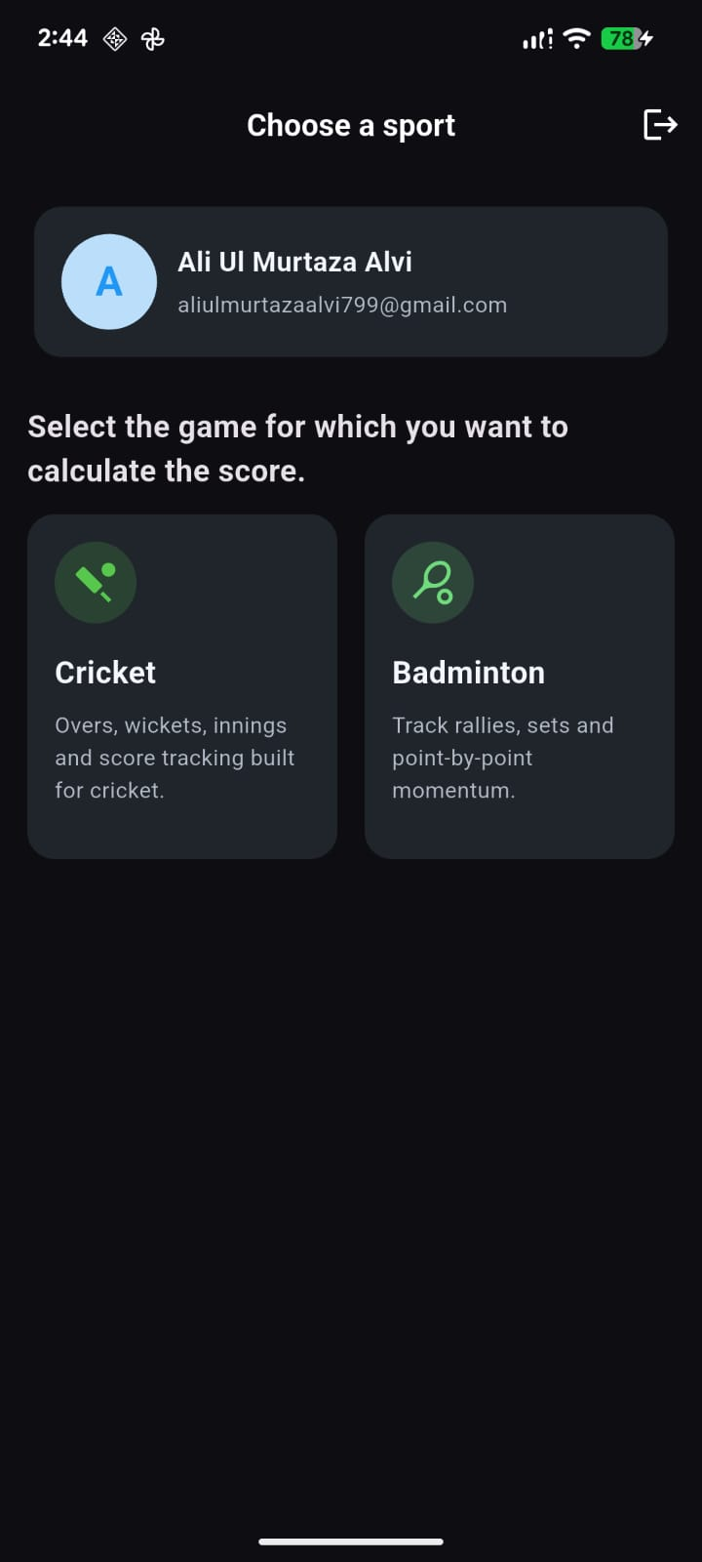

New Match Setup
Users select two teams, specify the number of overs, and conduct the toss to determine who will bat first. Includes robust form validation.

Cricket Scorer: Badminton Scorer:
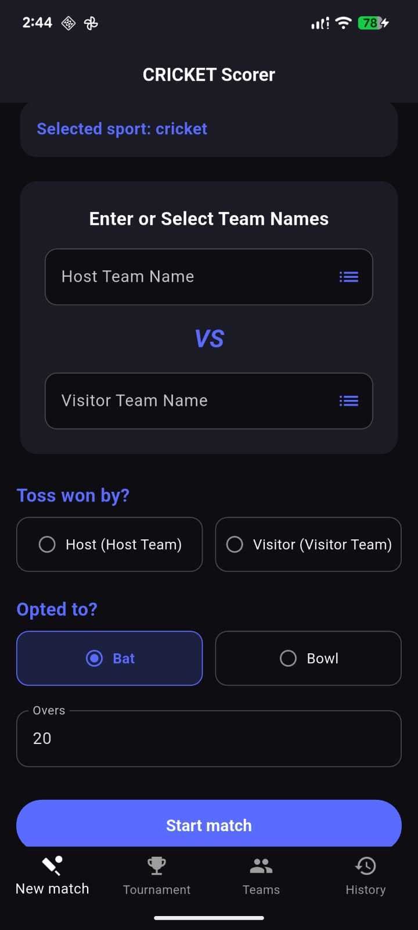
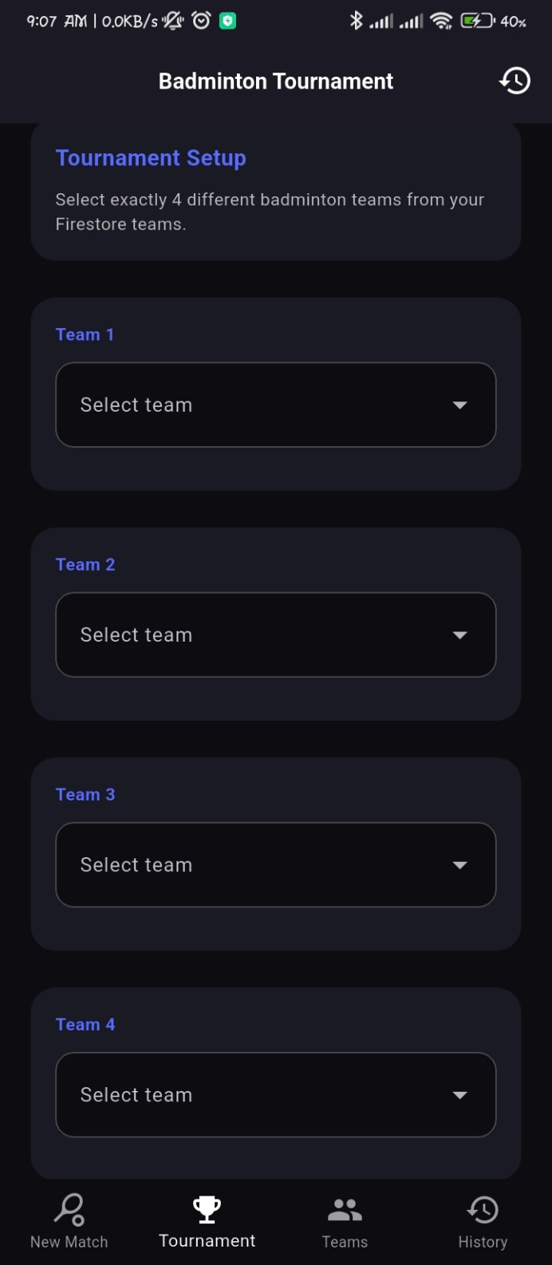

Live Scoring Interface
The core interface displaying current run rate, bowler stats, and batsmen scores. It features dedicated action buttons for runs, wickets, extras, and undo operations, powered by Riverpod state providers.

Cricket Score Board: Badminton Score Board:
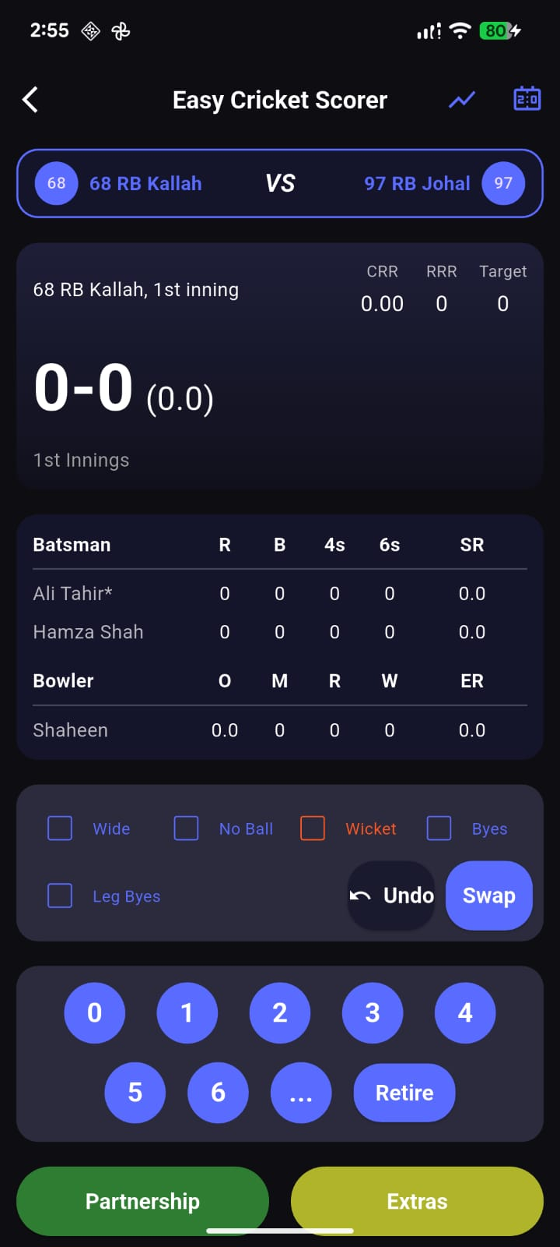
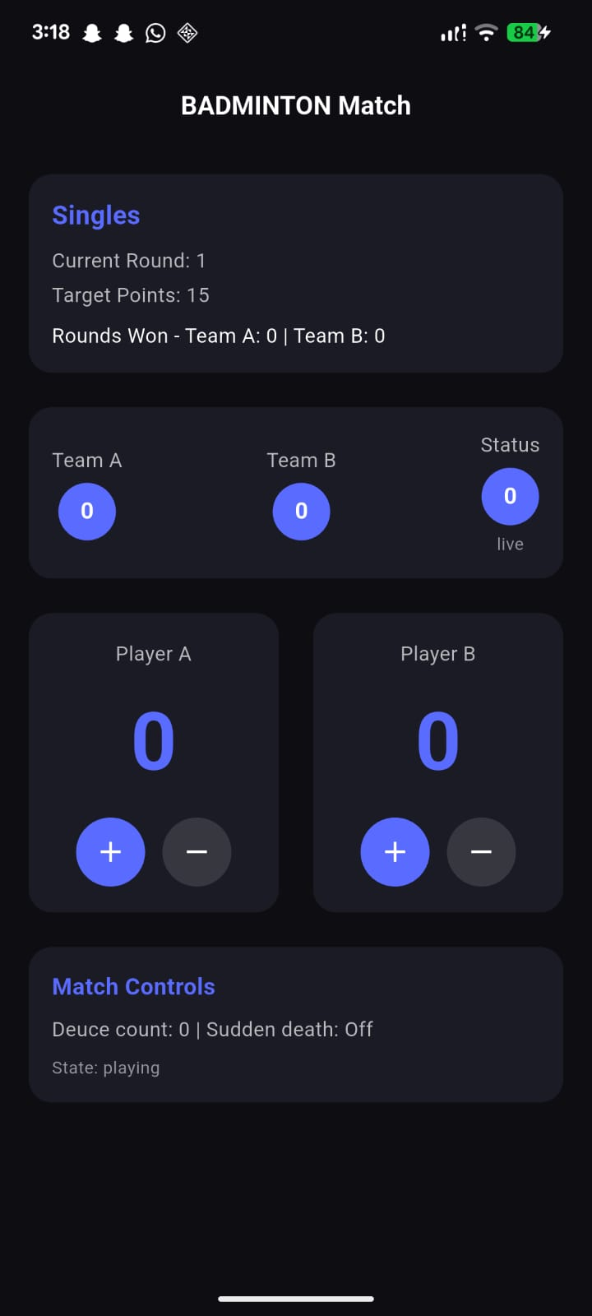

Tournament Dashboard
Displays participating teams and a dynamically updated points table reflecting wins, losses, and NRR (Net Run Rate).

Cricket Tournament Screen:
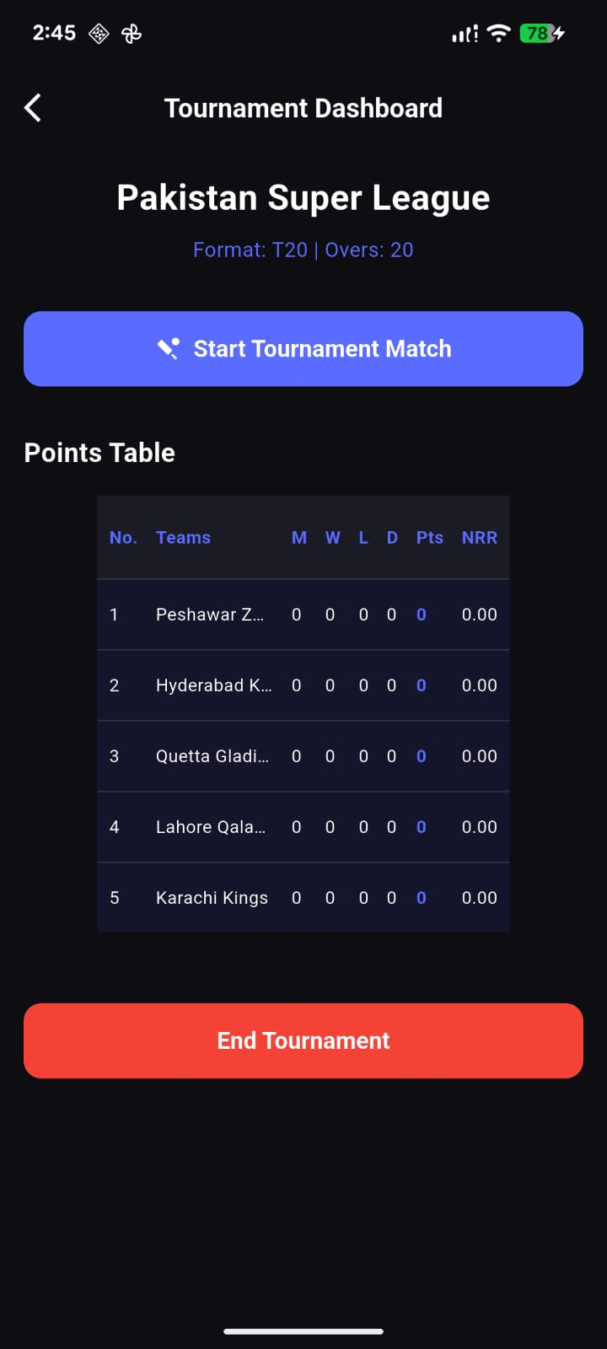
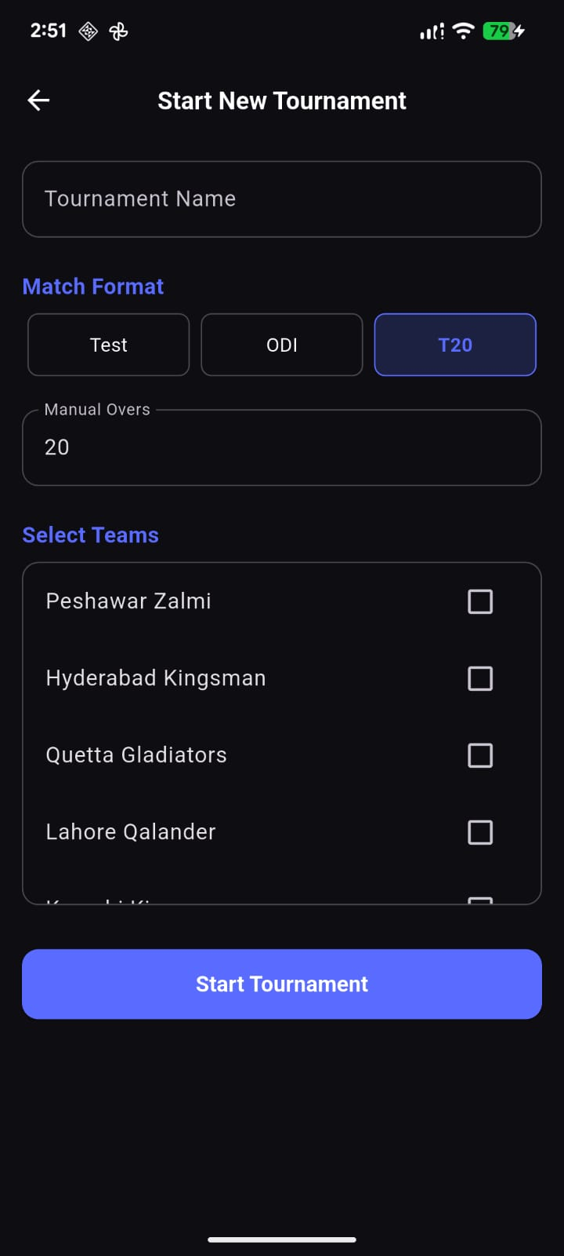

Badminton Tournament Screen:
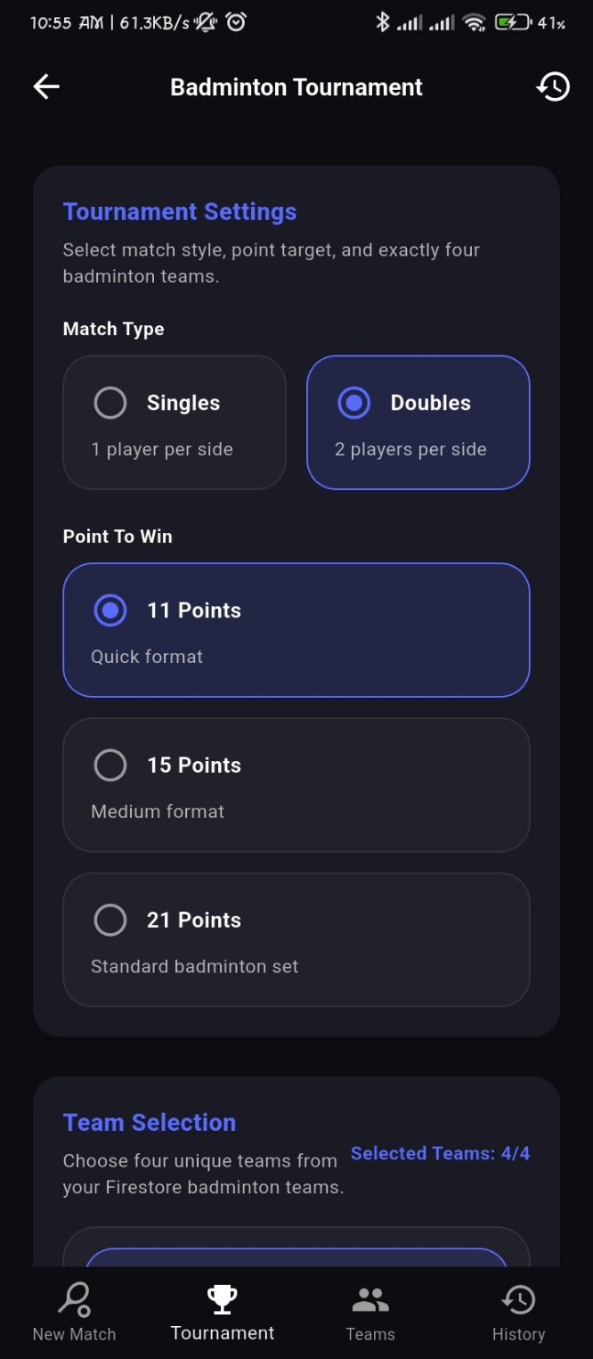
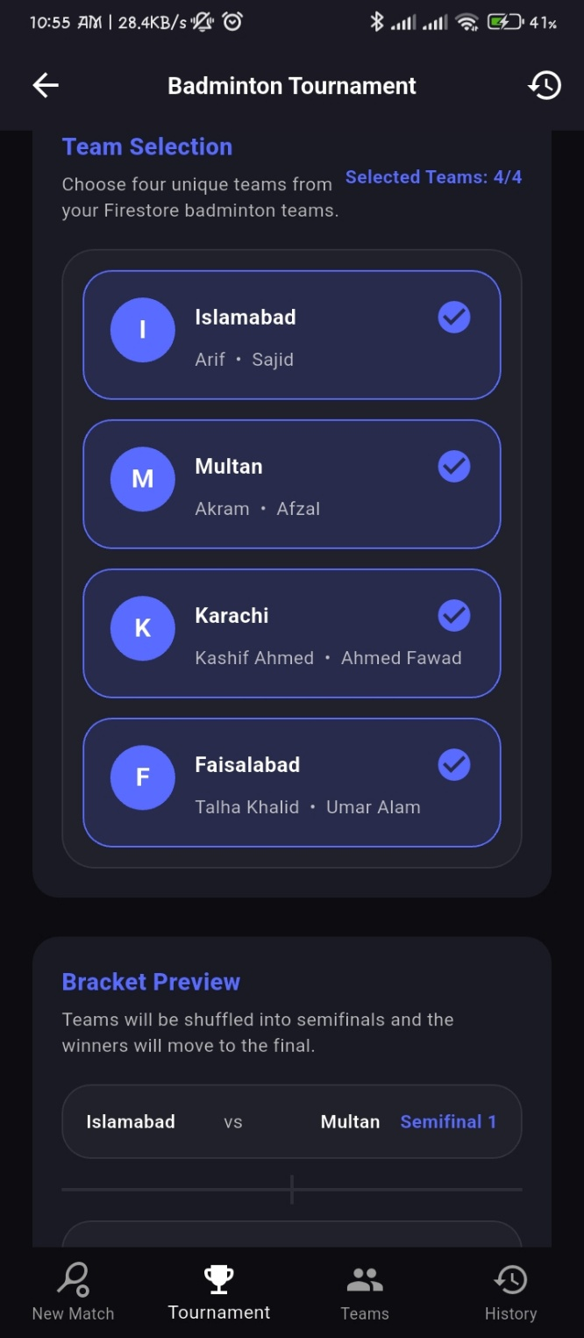

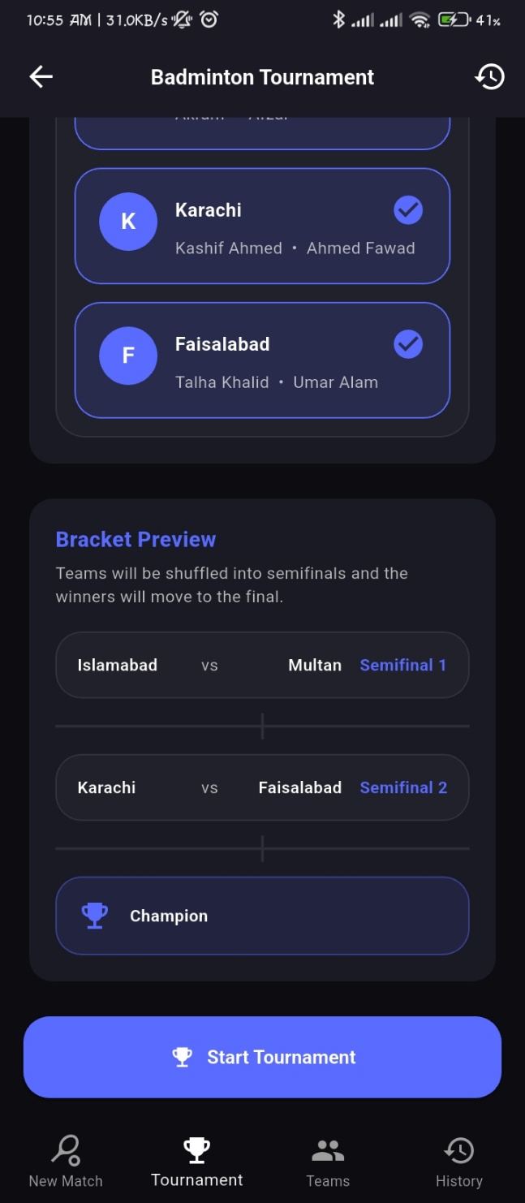

Teams Management
Allows users to create new teams, add players, and manage local rosters.

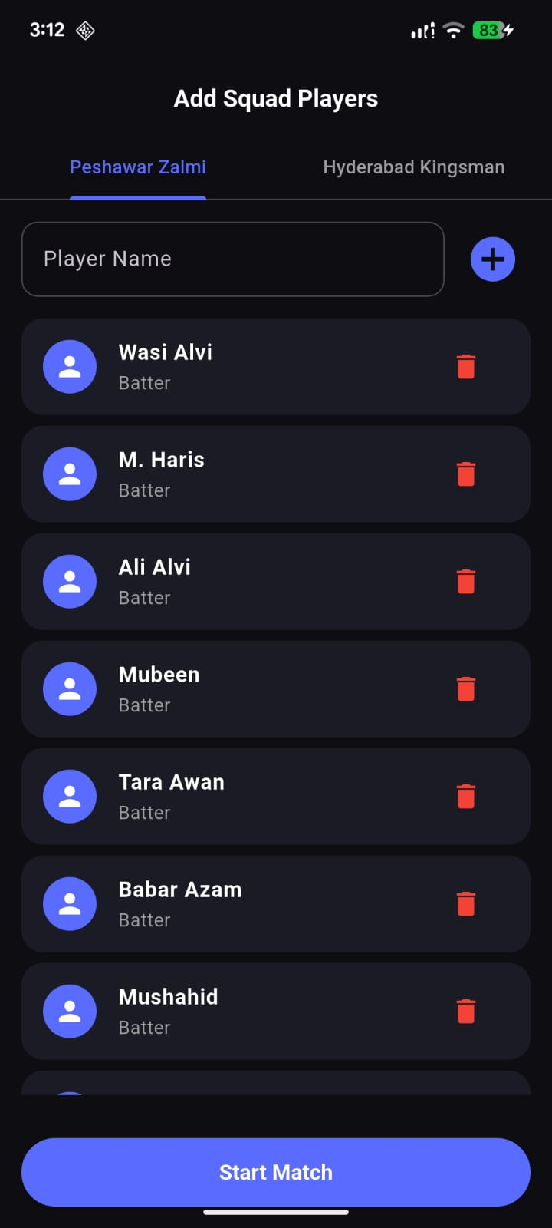
Cricket Model:
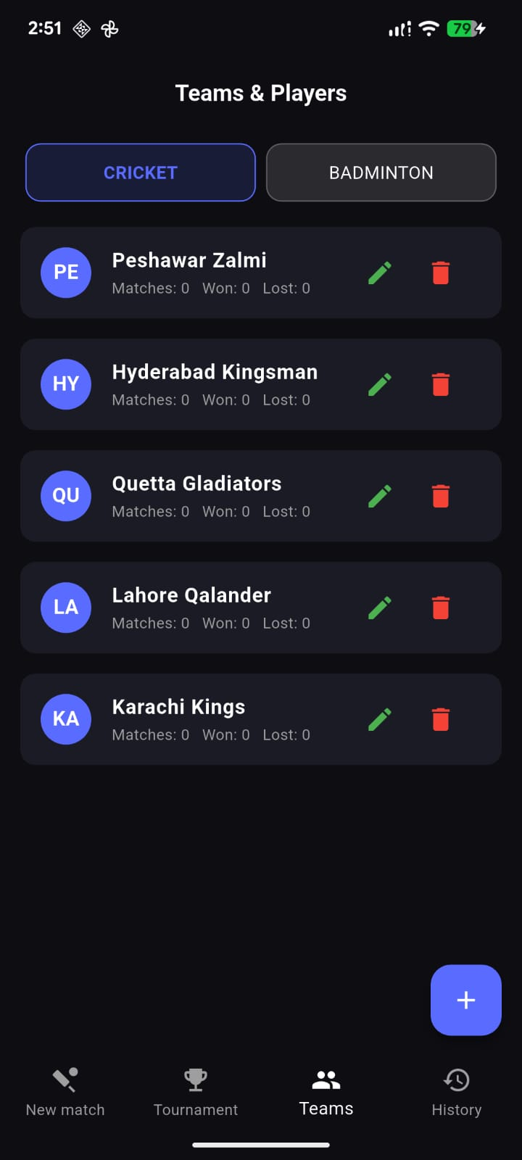

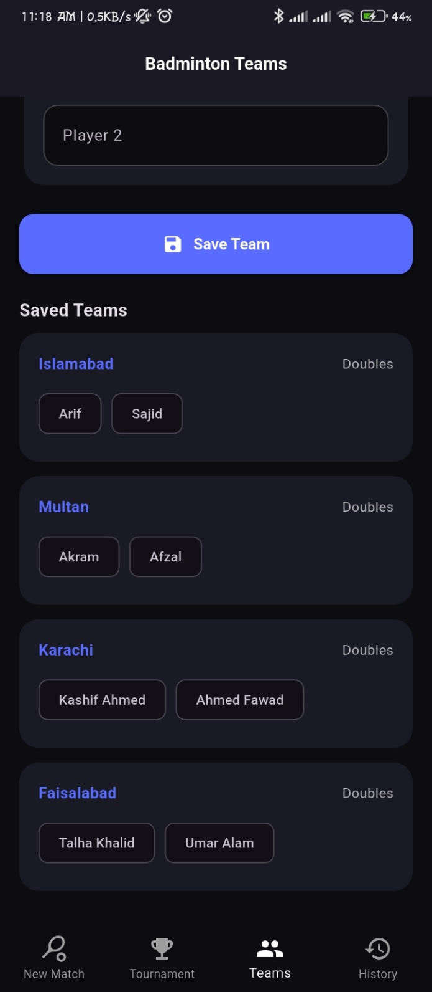
Badminton Model:
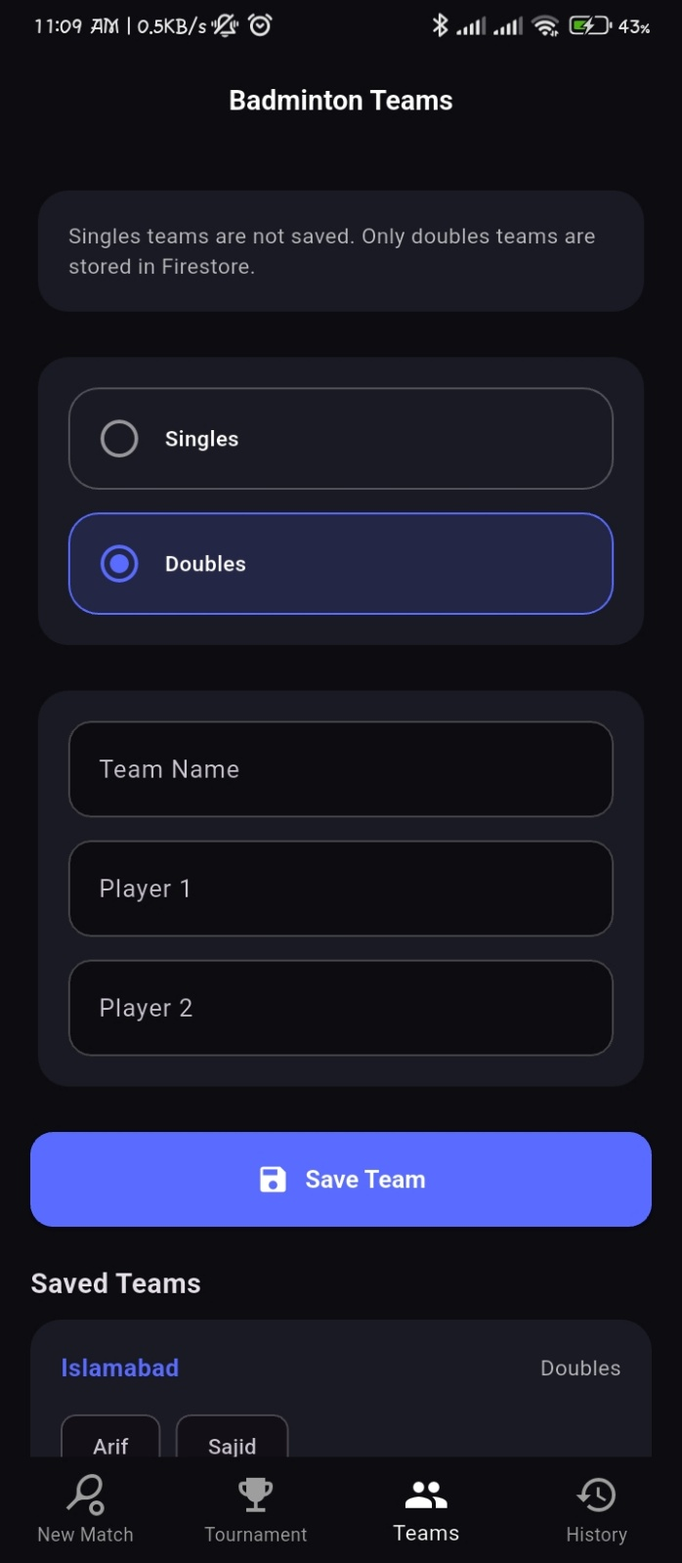

History Management

Cricket History:
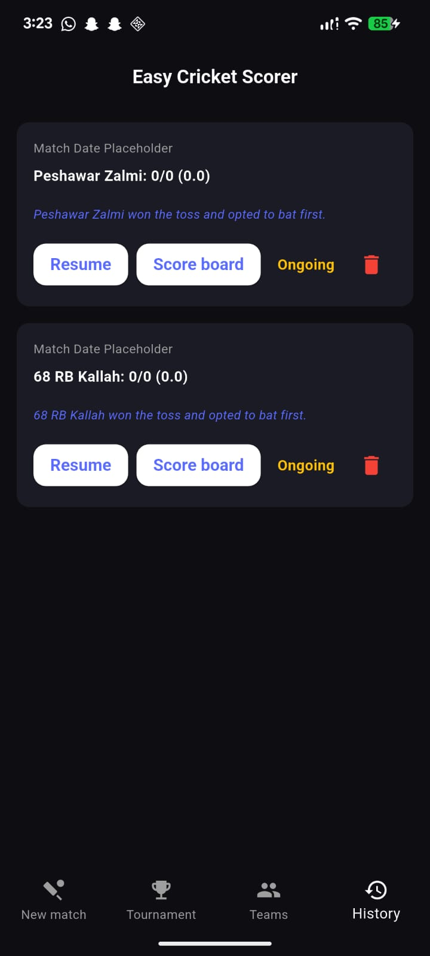

Badminton History:

Match Screen: Tournament Screen:
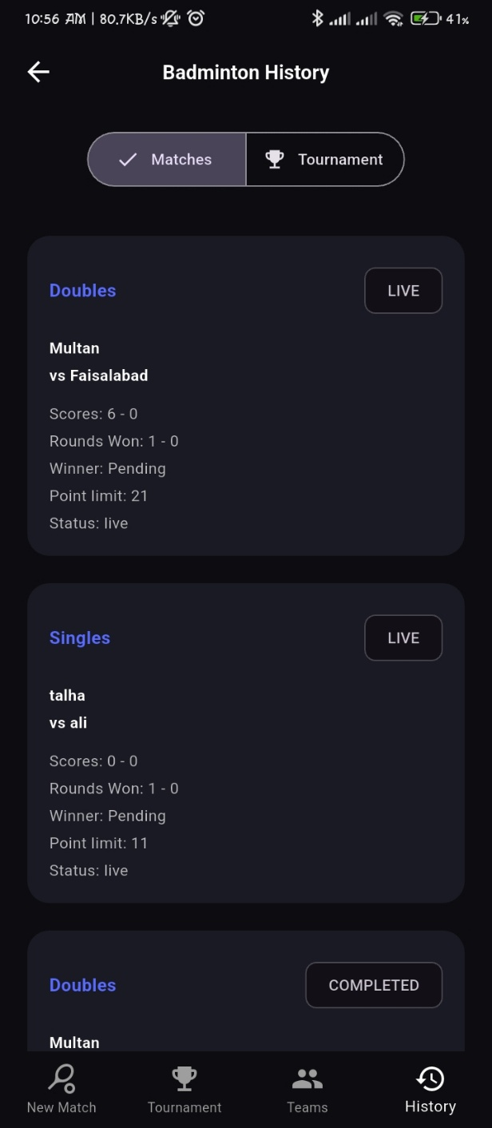
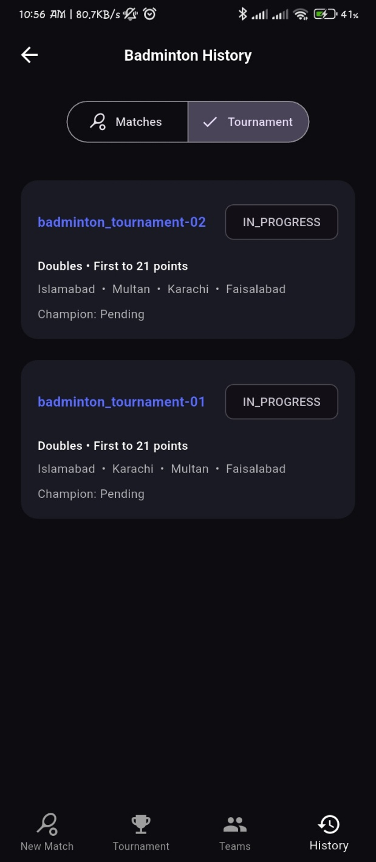

6. Tools & Frameworks
- Frontend Framework: Flutter (Dart) - SDK ^3.10.8
- Backend / Database: Firebase (Cloud Firestore, Firebase Auth)
- State Management: Riverpod (flutter_riverpod, riverpod_annotation)
- Code Generation: build_runner, freezed, json_serializable
- Routing: go_router

7. Installation & Setup
Prerequisites: - Flutter SDK installed - IDE (Android Studio / VS Code) - Firebase google-services.json config file
Setup Steps: 1. Clone the repository and navigate to the directory: bash cd smart_cricket_scorer 2. Get dependencies: bash flutter pub get 3. Generate immutable classes and providers: bash flutter pub run build_runner build --delete-conflicting-outputs 4. Run the application: bash flutter run

8. Application Architecture
The application leverages Riverpod for robust state management. Immutable data models are strictly enforced using Freezed, ensuring that live match states (e.g., scores, strike changes) are predictable and bug-free. Navigation is handled declaratively using GoRouter, allowing deep linking and structured path management.

9. Security & Privacy
- Authentication: Managed via Firebase Auth, ensuring isolated user environments.
- Data Integrity: Cloud Firestore rules ensure only authenticated users can write/modify match data.
- Testing: State management units ensure accurate run tracking across app sessions. flutter_lints is strictly enforced to maintain code quality.

10. Version Control
- The project is managed using Git and hosted on GitHub.
- Development is strictly modular, with feature branches dedicated to individual modules (e.g., feature/tournament-logic).

11. Packages Used
Package | Purpose in Project
flutter_riverpod | Core reactive state management
firebase_core & cloud_firestore | Real-time database and backend initialization
firebase_auth | User authentication
go_router | Advanced declarative routing and navigation
freezed_annotation | Code generation for immutable models
uuid | Generating unique IDs for matches, teams, and players
shared_preferences | Local storage for app settings

12. Future Enhancements
- Player individual career statistics tracking.
- Live broadcasting of scores via a public web link.
- PDF/Excel export capabilities for comprehensive match summaries.
- Advanced DLS (Duckworth-Lewis-Stern) calculator integration.

